Target to learn: HTML, CSS, **Java script**, Bootstrap, Typescript, **Angular/ ReactJS**.

We use above technologies for creating UI (User Interface) pages.

UI – User Interface – Which ever user experiences that page is called as UI page / Browser page.

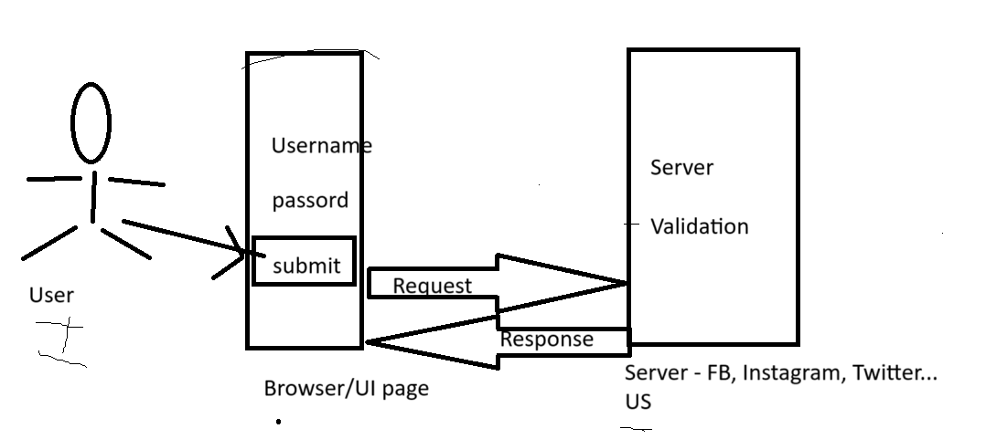

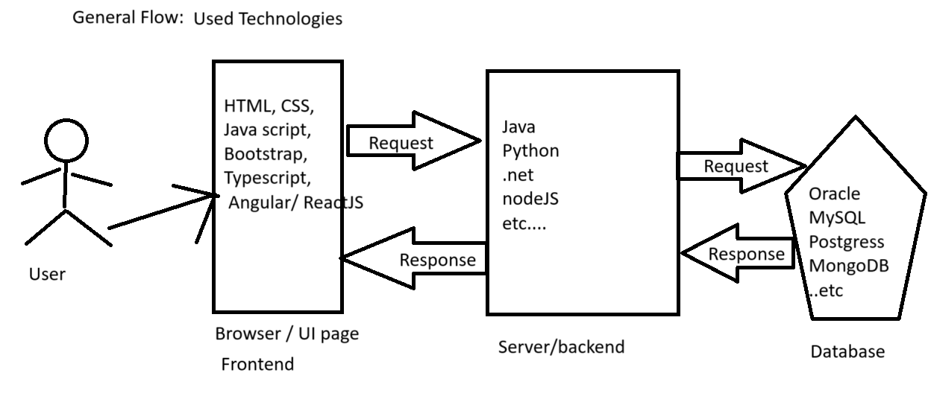

**Validation?** – Checking the user entered details (user name, password, email, phone number etc..) at server side or client side is called as Validation.

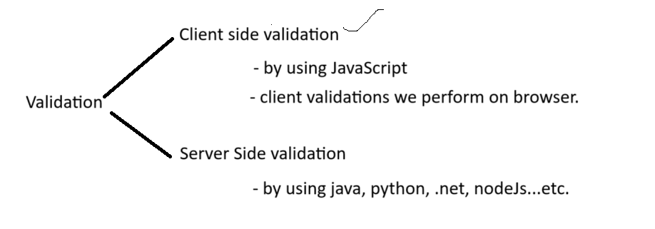

Server or Client always perform validation on user given input data.

Response is two types🡪 Valid response / Error response.

Browser**?** 🡪 HTML page rendering/ displaying location. It internally has engine to execute UI technologies.

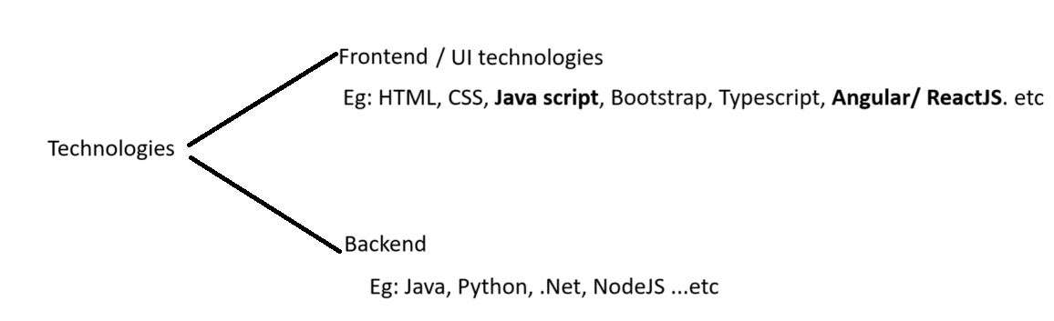

Browser:

How many browsers are there in the market? 🡪 So many browsers are available in the market.

What are they? Tell me 4 browsers?

Different companies created different browsers. Based on **browsing speed, memory usage** we use different browser.

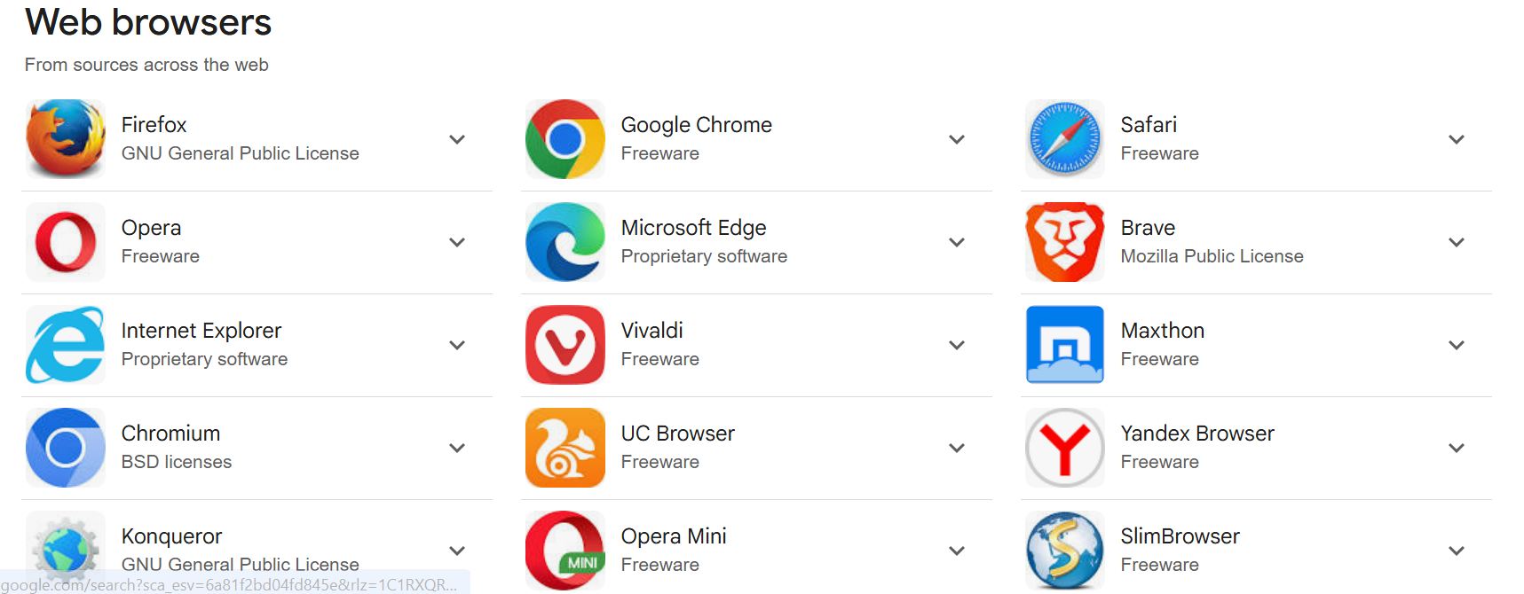

Which technologies can a browser understand? **HTML, CSS, Javascript**.

A browser can execute/run only **HTML, CSS, Javascript** files.

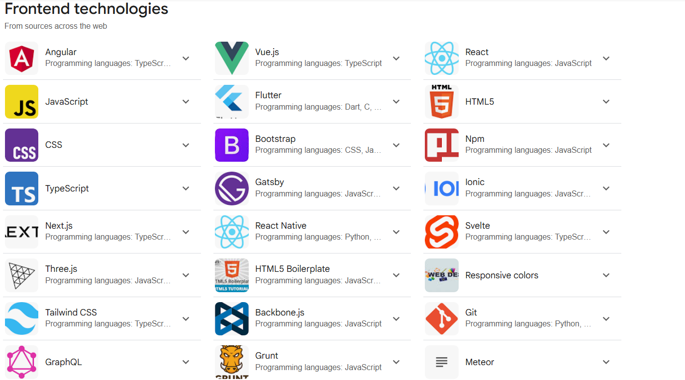

Then what about other UI technologies? How they run in browser? ->

For example, Angular or ReactJs how they run in browser? 🡪 First, we convert/compile/transpile the angular/reactjs into JavaScript code then we run in browser.

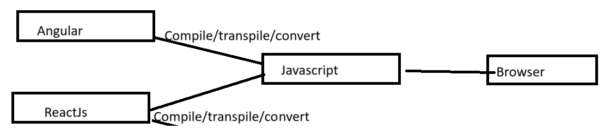

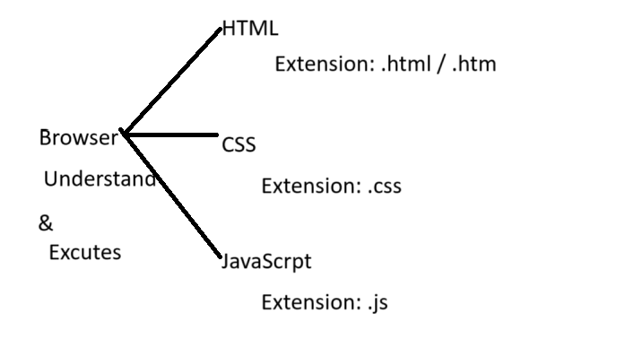

What is meant by Extension 🡪 It is File format.

How to create these files? 🡺 Left/Right Arrow mark.

**<anyName>.extension**

<anyName>.html, <anyName>.css, <anyName>.js

Extension? -> Which tells which type/format of the file we are going to create.

Eg: for TEXT file we use extension as **.txt**

for WORD file we use extension as **.docx**

for PDF file we use extension as **.pdf**

for JAVA file we use extension as **.java**

for IMAGES file we use extension as **.jpeg, .png, .gif….**

for HTML file we use extension as **.html / .htm**

for CSS file we use extension as **.css**

for Javascript file we use extension as **.js**

**etc…………………………..**

**Abbreviations:**

**HTML 🡪 Hyper Text Markup Language.**

**CSS 🡪 Cascading Style Sheet.**

**HTML**

<https://www.w3schools.com/>

Browser engine will run/execute content on html page.

Content means? 🡪 Code we written.

**In HTML page we can write HTML code, CSS code and JS code combinedly.**

How many ways we can write HTML tags/CSS code/JS code inside html page?

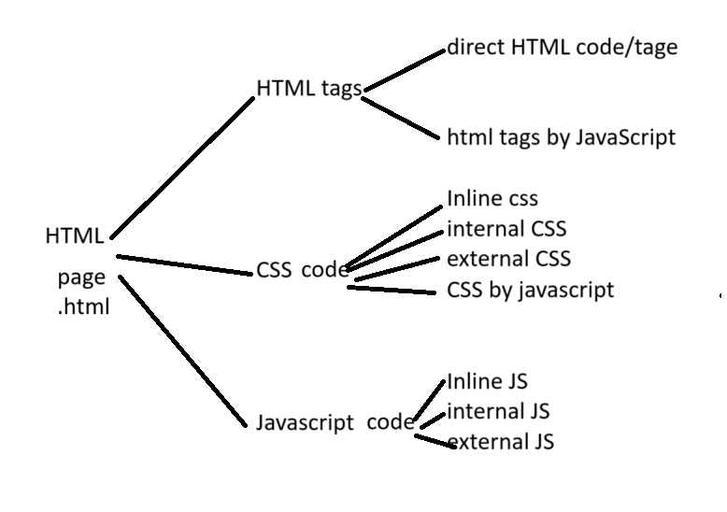

What is html tag/element? Why we write tag?

How to write html tag? A tag contains open tag and closing tag.

|  |
| --- |
| **<tagName>** --> opening tag  content  **</tagName>** --> closing tag |

Tags we always write in NESTED format. Writing tags inside another tags. **Tag inside another tag.**

**Tag is also called as ELEMENT.**

HTML stands for Hyper Text Markup Language.

HTML is the standard markup language for creating Web pages / Websites.

HTML describes the structure of a Web page.

HTML consists of a series of elements.- Number of tags.

HTML elements tell the browser how to display the content.

|  |
| --- |
| <!DOCTYPE html>  <html>  <head>  <title>Page Title</title>  </head>  <body>  <h1>My First Heading</h1>  <p>My first paragraph.</p>  </body>  </html> |

What is the basic structure of html page?

Root tag / parent tag.

Child tags.

The **<!DOCTYPE html>** declaration defines that this document is an HTML5 document

To convert our html page to HTML 5 version html page.

The <html> element is the root element of an HTML page

The <head> element contains **meta information** about the HTML page 🡪 Data about data-Meta data. High level information.

The <title> element specifies a title for the HTML page (which is shown in the browser's title bar or in the page's tab)

**The <body> element defines the document's body,** and is a container for all the visible contents, such as headings,

paragraphs, images, hyperlinks, tables, lists, etc.

**Whatever the content we have written inside <title> tag will be displayed inside **window tab location**.

**Whatever the content we have written inside <body> tag will be displayed inside **document location**.

**Brower objects:**

window** 🡪 Overall browser is called as window.

document****** 🡪 White screen inside browser is called as document.

location 🡪 URL bar location is called as location.

Etc…

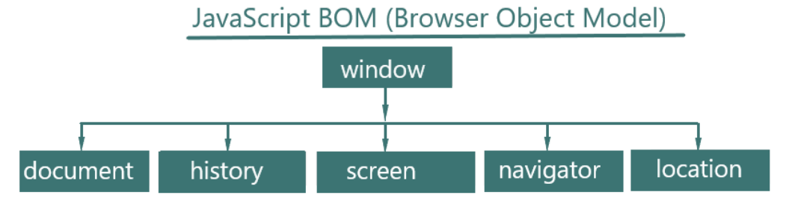

The <h1> element defines a large heading

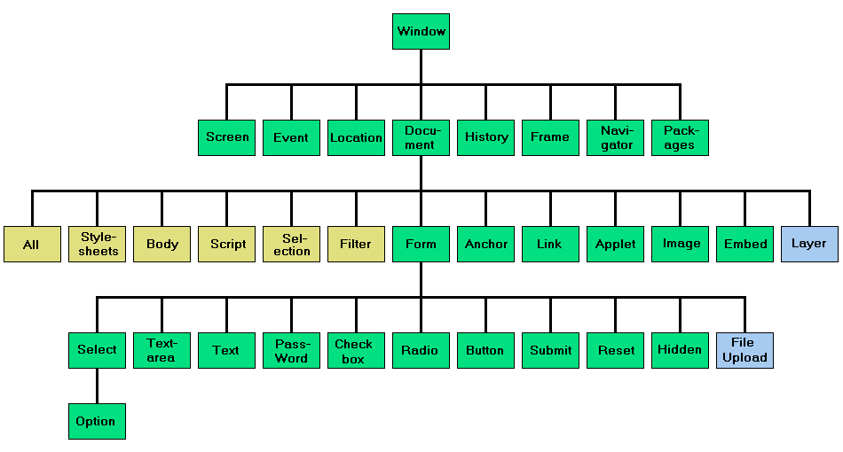

The <p> element defines a paragraph

<br> 🡪 Empty tag. Used for the breaking the line.

<h1> 🡪 It is a Heading tag, To increase the size of the text we use heading tag.

Heading tag range is from <h1>…to <h6>.

Editors: notepad, notepad++, **VSCode,** Atom editor, Brackets….

We use VSCode, why VSCODE?

VSCode has auto completion feature. Automatically it prompts the required tags and their details.

What is meant by case sensitive? Is html being case sensitive? Is java being case sensitive?

Case sensitive means- upper case letters and lower-case letter.

For example: html engine treats <html> tag and <HTML> tag as same. There is No error.

<a> 🡪 Anchor tag/element. Use for hyperlinks.

**Every html tag has attributes.**

Attributes are used to provide additional information about HTML elements.

<img> 🡪 used to display images on document / browser.

|  |
| --- |
| **<img src="instagram2.ico" width="50" height="50" alt="instagram image...."/>** |

Here <img**/>** is a **self-closing tag**. Means we are not writing the closing tag. We are closing the tag in open tag only.

View HTML Source Code. 🡪 we can see all websites source code. right click on browser 🡪 select “view page source”

**Inspect** (**Developer Tool**) is a browser feature 🡪 right click on browser 🡪 select “Inspect”

We can see source code in “**Elements**” tab.

We can use JavaScript “**Console**”

We can see html page “**sources**”, means we can see source page location.

We can see request “**network**” information.

HTML attributes provide additional information about HTML elements.

Attributes are always specified in **the start tag.**

**title** attribute is used for tooltip. It always gives extra information.

**\*\* Id** attribute is used to identify tag/element uniquely. We should not duplicate the id **value** with other tags id values.

<p id=”**empId**” title=”My Title” class=”myClass”> This is My First Paragraph</p>

<p id=”**empId**” title=”My Title” class=”myClass”> This is My Second Paragraph</p> 🡪 WRONG

**Question:** What is the difference between <title> tag and title attribute?

we always write HTML Attributes in **key=”value” format** OR **htmlAttrubuteName=”value”** format. Eg: id=”empId”.

we always write CSS Attributes in **key: value format** OR **cssAttrubuteName:value** format. Eg: “color:red”; .

: 🡪 is called as Column

; 🡪 is called as Semi-Column.

**URL**: (**U**niform **R**esource **L**ocator)

1. **Absolute URL.** – Complete URL path which is available in another server / host.

<https://static.xx.fbcdn.net/rsrc.php/yB/r/2sFJRNmJ5OP.ico>

1. **Relative URL** - Links to an image that is hosted within the website. Here, the URL does not include the domain name.

Eg: src=”/images/facebook.jpeg”

Domain name? – <https://www.facebook.com> website name is called as domain name.

Style attribute:

So far, we know id attribute, class attribute, title attribute along with this we have another important attribute called “style”. Style means it is CSS style. Cascading **Style** Sheet.

The HTML style attribute is used to **add styles to an element, such as** **color, font, size**, and more.

Syntax:

<*tagname* style="*property*:*value;*">

Eg:

<p **style="color:red; font-size: 50px;**"> I am red </p> 🡪 Inline style.

|  |
| --- |
| <p **style="color:red; font-size: 50px;**"> I am red </p>  <p **style="color:red; font-size: 50px;**"> I am red </p>  <p **style="color:red; font-size: 50px;**"> I am red </p>  <p **style="color:red; font-size: 50px;**"> I am red </p>  <p **style="color:red; font-size: 50px;**"> I am red </p> |

Styles:

1. **Inline style** -> problem, code had to be duplicated.
2. **Internal style** -> <style> tag inside html page.
3. **External style ->** we create .css file and Import in all required .html pages.
4. Styles with JavaScript.

In order to overcome problem with inline style, they introduced internal style.

In internal style we are writing **<style>** tag/ element inside HTML page.

Eg: **test.html**

|  |
| --- |
| <style>          p {              background-color: green;              font-size: 50px;              width: 550px;              font-family: Verdana, Geneva, Tahoma, sans-serif;              height: 150px;          }      </style> |

|  |
| --- |
| <!DOCTYPE html>  <html>  <head>      <title>My Page</title>  </head>  <style>  **p { // here P is called as “selector” 🡺 Find and Apply.**      background-color: green;      font-size: 50px;      width: 550px;      font-family: Verdana, Geneva, Tahoma, sans-serif;      height: 150px;  }  </style>  <body>      <p>AAAAAAAAAAAAAAA</p>      <p>AAAAAAAAAAAAAAA</p>      <p>AAAAAAAAAAAAAAA</p>      <p >AAAAAAAAAAAAAAA</p>      <p>AAAAAAAAAAAAAAA</p>      <p>AAAAAAAAAAAAAAA</p>  </body>  </html> |

**Purpose of CSS “selector” is to find and apply the styles we defined.**

If we write inline style and internal style, which one takes priority? 🡪 Inline style only takes priority.

External style:

1. Custom .css/.js file. 🡪 code written by us.
2. Predefined .css/.js file. 🡪 code written by someone else and we are using it by importing in our html file.

Even though we write internal style still code is getting duplicated. How?

If we create multiple HTML pages with same CSS code, then css code getting duplicated.

To overcome this problem, they have given external style concept.

We write separate .ccs file and we import that .css file into our .html file.

How to import external stylesheet ?

|  |
| --- |
| **one.html:**  **<link rel="stylesheet" href="my-style.css">**  <link href="https://cdn.jsdelivr.net/npm/bootstrap@5.3.3/dist/css/bootstrap.min.css" rel="stylesheet"> |

“rel” means relationship type.

In external style sheet we don’t required to write <style> tag.

Inline style.

We write **style attribute** inside HTML tag/element.

Internal style.

We write **<style> tag**/**element** inside .html page.

External style.

We write **separate .css file** and we import that .ccs file into .html page.

**<link rel="stylesheet" href="my-style.css">**

RCA -> Root Cause Analysis. Finding out the root cause.

CSS code priority: Inline style **>** internal style **>** External style.

Some CSS properties: color, background-color, font-size, font-family, font-weight, text-align (Here alignment means position), <sub>, <sup>, <b>, <i>, <del> (strike the content),

Whatever the changes we are doing by HTML attributes, we can do by CSS properties also.

**Comments**: Gives additional information about our project.

HTML comments are not displayed in the browser, but they can help document your HTML source code.

We can use **CTRL + forward Slash (/)** buttons for commenting code in VSCode.

HTML Comments:

<!- - my HTML Comments here

-------

-- >

CSS Comments:

/*

my HTML Comments here

my HTML Comments here

------

*/

JavaScript Comments:

1. **//** double forward slash

**/\***

my HTML Comments here

my HTML Comments here

------

**\*/**

**Debugging**: Finding out the error which we got in our application, is call debugging. Line by line checking the code is called as debugging process.

Comments are also great for debugging HTML.

We can write inline comments also. Means inside tag also we can write the comments.

<p id=”empId” > This is My First **<!-- Paragraph -->** </p>